Types of Deserts
Hot Deserts – These lie just north or south of the equator where the sun’s rays are the hottest. They can be very hot in the day but freezing during the night. Animals found in the Sahara Desert include: camels, desert foxes, dung beetles, snakes and lizards.
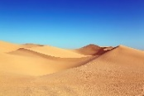  Sahara Desert | This used to be a lush region with many plants/animals but dried out 4000 years ago and is one of the hottest places on Earth (up to 46°C) but often below freezing at night. Known for sand dunes and salt flats.
Cold Deserts - Although cold deserts have hot summers, they also have freezing winters. Many scientists even see Antarctica is a type of cold desert because it gets very little rain or snow. Animals found in the Gobi Desert include: camels, bears, gazelles, jerboas, vipers, ibex snow leaopards, golden eagles and polecats.
Gobi Desert  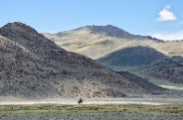 | This desert covers 1.3million km² which is largely made up of bare rock. Its northern location and situation high above sea-level means it is largely a cold desert with snow often arriving from Russia. Temperatures can vary greatly from 37°C in summer to -21°C in winter.
Coastal Deserts – These deserts are found on coasts where the land meets the sea. Winds come from the ocean and can bring huge amounts of fog. This roles over the desert. The sun causes it to evaporate and not fall as rain. Animals found in the Namib Desert include: chamelions, spiders, gerbils, horses, cheetahs and zebras
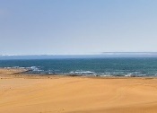  Namib Desert | Aging from between 55-80 million years old, this desert is the oldest in the world and is one of the world’s driest regions. Sand dunes can reach up to 300m in height and temperatures (although cooler on the coast) can reach up to 45°C inland.
Humans
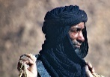  Desert Peoples | Despite the desert being so hard to survive in, there are groups living in these places. They have to keep moving risking sandstorms, blocked wells and getting lost. Some of these peoples are the Berbers (Sahara Desert), the Bedouins (Arabian Desert), the Bejas in (Namib Desert), the Sans (Kalahari Desert) and the Australian Aborigines.
  Desert Cities | Some cities build up in desert areas where there is a nearby water supply. Hoover Dam was built to provide power, irrigation, and water to Las Vegas (U.S.A.) and the surrounding area. Saudi Arabia discovered billions of barrels of oil and gas which it could mine. The money it brought, and the energy it has created using it, has meant large cities have developed over time (e.g. Riyadh).
Key Vocabulary
abrasion | the process of scraping or wearing something away
arid | having little or no rain; too dry or grow vegetation
blowout | a hollow blown out by the wind
canyon | deep gorge with high cliffs formed from a river
drought | a period of time with so little rain, crops do not grow
erosion | the wearing away of the land
irrigation | the supply of water to crops from rivers
nocturnal | due to heat, many animals sleep in the day and hunt at night
nomadic | moves from place to place / hunter-gatherer
oasis | lush, green area with water around a natural spring/well
plateau | High, flat land where cold deserts can be found
precipitation | any form of water that falls to the ground (rain, sleet, snow etc)
salt flats | a large, flat area of ground covered with salt and minerals
sand dunes | hill of loose sand built through wind
sandstorm | caused by very strong gusts of wind
Deserts

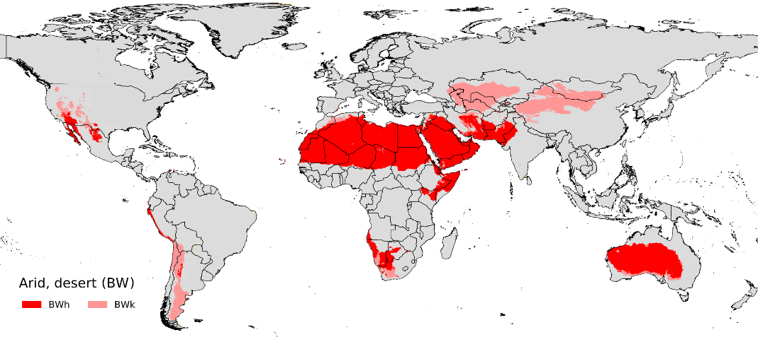
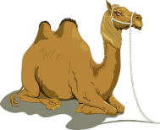
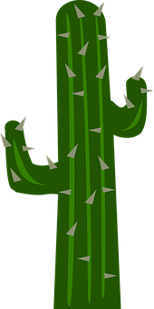
Deserts are the driest places on Earth. There are three types of desert (hot, cold and coastal) but all of them have very little rainfall, strong winds and very few animals and plants. Therefore, deserts can be made up of sand, rock, gravel and even ice. Only animals and plants that need very little water can survive in this environment. When it finally does rain, it can be huge amounts and cause flooding. Some deserts can go years without seeing any rainfall at all.
Equator
Atacama Desert
Arabian Peninsula
Great Sandy Desert
Gobi Desert
Namib Desert
Sahara Desert
https://upload.wikimedia.org/wikipedia/commons/4/48/BW_climate.png
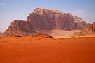
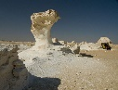
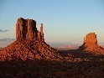
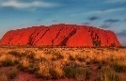
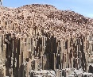
Fact Box
The driest desert is the Atacama Desert in Chile. It only gets 1mm of rain in an entire year.

33% (1/3) of the Earth’s surface is classified as desert.

Great Basin Desert
BIGGEST DESERTS
Sahara Desert = 9.2million km²
Antarctic Desert = 8.9million km²
Arctic Desert = 8.5million km²
Arabian Desert = 2.33million km²
Gobi Desert = 1.3million km²
Kalahari Desert = 0.9million km²

Map of Deserts Around the World
Uluru The Organ Pipes Monument Valley The White Desert Wadi Rum
(Australia) (Namibia) (U.S.A.) (Egypt) (Jordan)
Desert Rock Landforms
Within a desert landscape, landforms are created such as mountains, hills or strangely shaped rocks and structures. Valleys and canyons also form. They are formed over thousands of years due to heat, wind and water (rivers/rain) which causes weathering and erosion of the rocks. The softer rock is broken down leaving the hardest rock behind.

Adapting to Survive
Adaptation is a change in a plant or animal’s body to suit its location. It evolves over thousands of years in the most efficient way, allowing them to survive in hot deserts.
A cactus stores water to help keep it alive in the desert. It also has spikes to protect itself from attack.
A camel has humps of fat storage to use up for energy in the dry desert when there is a shortage of food.

