February 2024
Dear Parents/Carers,

I am writing to you as the Key Stage 2 French Teacher/lead at Holy Trinity Primary School. It has been wonderful getting to know the children this year. All the interest and enthusiasm they have brought to our French lessons has been wonderful and thoroughly inspiring!
I’d like to bring to your attention that our school has a subscription to the award-winning platform Linguascope (https://www.linguascope.com).
Linguascope is a website offering interactive resources in French, Spanish, German, Italian, Portuguese, Mandarin Chinese, Arabic, Russian, Polish, Welsh, Scottish Gaelic, Maori, and English to match curriculum requirements. We, of course, at school are focusing our attention on the French resources.
Organised in topic areas, the materials are presented via a host of immersive multimedia activities. The site covers all topics encountered in lessons throughout the year and also includes printable worksheets.
As part of our licence, all our students can access the Linguascope website from home. The website can be used independently by students to consolidate what they have learned in class, revise for upcoming tests, get a head start learning new vocabulary, or even introduce themselves to a new language.
The interactive activities are also tablet-friendly, with FREE iPad and Android apps that students can install on their mobile devices: https://www.linguascope.com/apps/
To log in to the platform, students have the username and password as detailed below:
Username: trinitysw
Password: greendolphin58

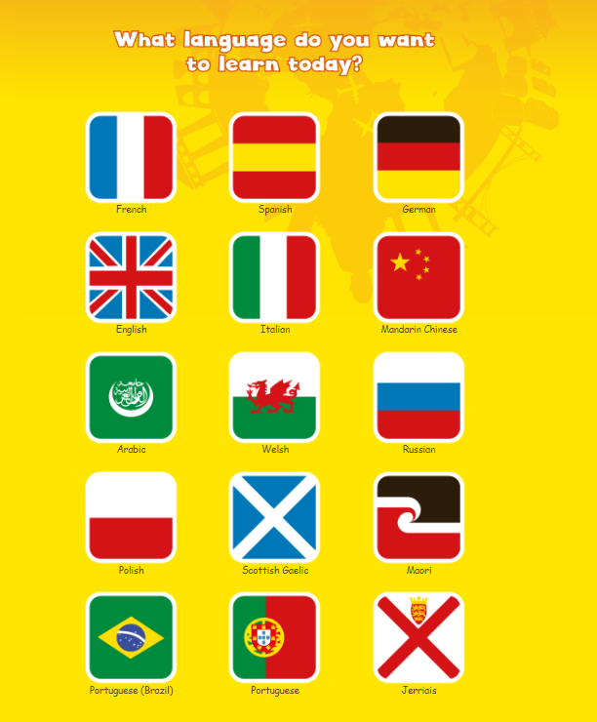
Once logged in, to access the French material, please click on the French flag. “Elementary” or “Beginner” are the sections that are most suitable for our Key Stage 2 children.

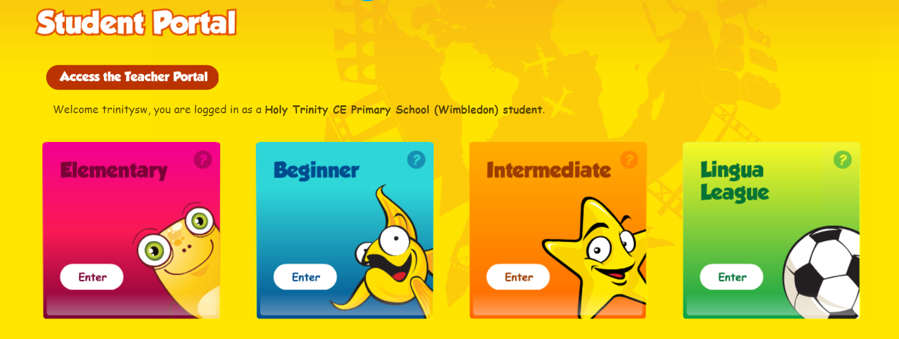
Our Key Stage 2 children will find Elementary and Beginner sections most useful and relevant to their current learning

Useful topic areas we have been covering in French lessons are:
Year 3: Elementary Level (houlala), Bonjour, Ecoutez Moi (class instructions), ça va? (saying how you are),nombres 1-12 , couleurs, trousse (pencil case items)
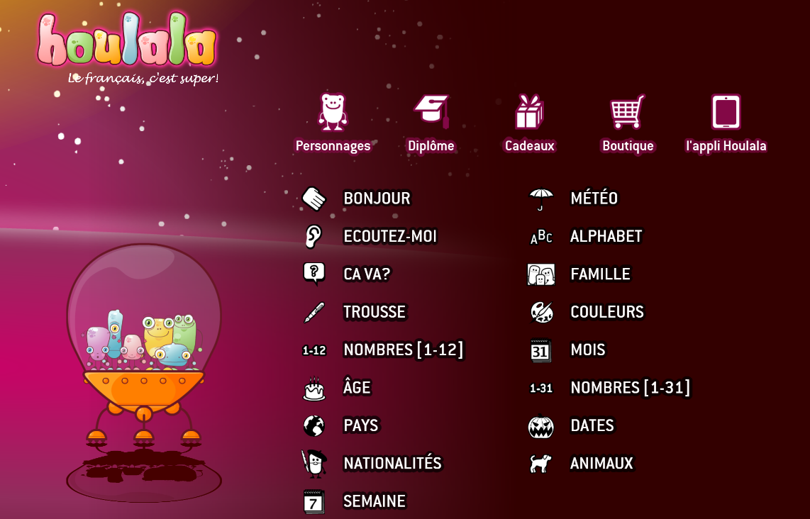
Elementary Level:
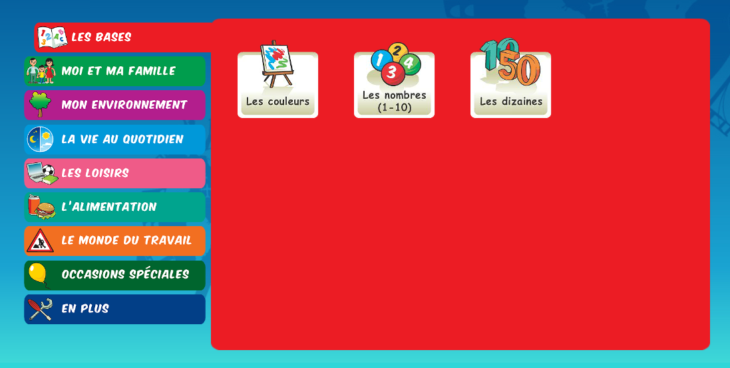
Beginner Level
Topic areas are down the side.
Specific vocabulary areas are found within these topic areas.

Year 4: Beginner level: Moi et Ma famille Section (me and my family) – Le corps and le visage (body and face). Les bases section (the basics) – les couleurs (the colours), mon environnement section (environment) - le temps (the weather)

Year 5: Beginner level: – l’alimentation section (food)– les fruits et les legumes (fruit and vegetables), les loisirs section (leisure) – les instruments de musique.

Year 6: In beginner - Mon environnement section– En ville (in town), les magasins (the shops),
les bases (basics)section – numbers review, l’alimentation section – review of food and drink words.

For all year groups, all areas in Elementary level are particularly useful for review of all prior learning.
It is always useful to click on the Presentation section of each topic area, as this allows the children to easily read and listen to the target words/phrases. This then allows them to approach the other activities more confidently and successfully. These activities include: memory game, snap, noughts and crosses, find the hidden words, self-recording with play back and many more.
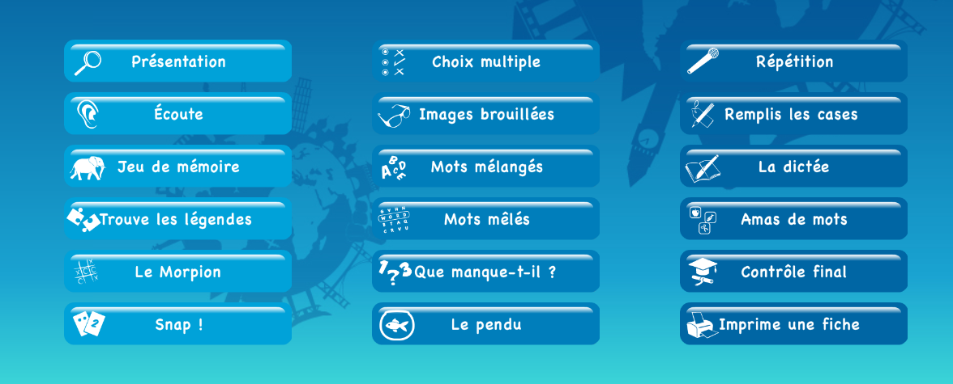

The children are, of course, welcome to explore the whole platform (including other languages!) and have a go at what they would like to.
As we cover different topics, I will make reference to linguascope in class, so they know what resources are available and how they can access them at home. Please don’t hesitate in getting in touch if you have any questions.
Yours sincerely,
Anthia Poleviou
Mrs. Anthia Poleviou
(Teacher of French, Holy Trinity Primary School)

